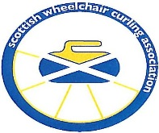
BRITISH OPEN WHEELCHAIR CHAMPIONSHIP 2022
28th February- 2nd March 2022
PEAK ICE RINK STIRLING

Application Form Overseas Entries
Team Entry Form

ENTRY FEE RULES OF PLAY
£200 per Team 8 ends or the Bell will be played
Teams will be of Mixed Gender

CLOSING DATE FOR ENTRIES Friday 29 October 2021
TEAM

Skip _____________________ Second ____________________

Third _____________________ Lead ____________________

Skip contact details
Email _____________________________Tel ____________________________

Overseas Teams will have to make their own travel arrangements from the Airport to the Venue.
A list of suitable hotels can be supplied by the organisers, Teams will need to book and arrange this directly with the Hotels.

Completed Entry Form along with entry fee (cheques payable to SWCA) should be sent to:

Treasurer: Rosemary Lenton , Makbrar Wynd, Dumfries, DG1 4XD.

Note: Entry fee will not be refunded after the closing date for entries, due to payment for ice which will be due to Ice Rink

